|  |  |
| --- | --- |
| *Name* | *Fragrances* |
| *Color* | ***Red*** |
| *Size* | ***245ml*** |
| *Brand* | ***Chloe*** |
| *Price* | ***PKR 300*** |

|  |  |
| --- | --- |
| *Name* | *Fragrances* |
| *Color* | ***Light Yellow*** |
| *Size* | ***500ml*** |
| *Brand* | ***Chloe*** |
| *Price* | ***PKR 350*** |

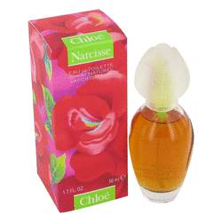

|  |  |
| --- | --- |
| *Name* | *Fragrances* |
| *Color* | ***Light Brown*** |
| *Size* | ***300ml*** |
| *Brand* | ***Chloe*** |
| *Price* | ***PKR 350*** |

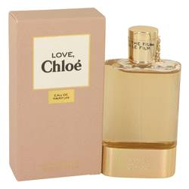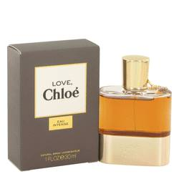

|  |  |
| --- | --- |
| *Name* | *Fragrances* |
| *Color* | ***Green*** |
| *Size* | ***120ml*** |
| *Brand* | ***Chloe*** |
| *Price* | ***PKR 350*** |

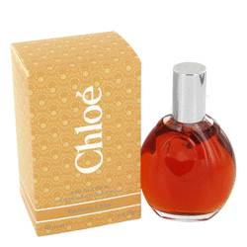

|  |  |
| --- | --- |
| *Name* | *Fragrances* |
| *Color* | ***Red*** |
| *Size* | ***100ml*** |
| *Brand* | ***Chloe*** |
| *Price* | ***PKR 3500*** |

|  |  |
| --- | --- |
| *Name* | *Fragrances* |
| *Color* | ***Green*** |
| *Size* | ***500ml*** |
| *Brand* | ***Chloe*** |
| *Price* | ***PKR 350*** |

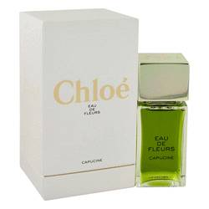

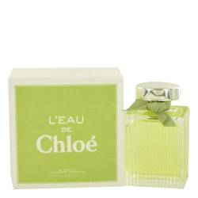

|  |  |
| --- | --- |
| *Name* | *Fragrances* |
| *Color* | ***White*** |
| *Size* | ***400ml*** |
| *Brand* | ***Chloe*** |
| *Price* | ***PKR 350*** |

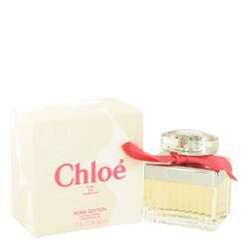

|  |  |
| --- | --- |
| *Name* | *Fragrances* |
| *Color* | ***White*** |
| *Size* | ***500ml*** |
| *Brand* | ***Chloe*** |
| *Price* | ***PKR 350*** |

|  |  |
| --- | --- |
| *Name* | *Fragrances* |
| *Color* | ***Silver*** |
| *Size* | ***120ml*** |
| *Brand* | ***Chloe*** |
| *Price* | ***PKR 350*** |

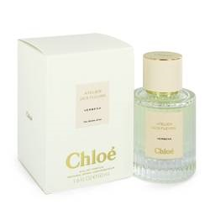

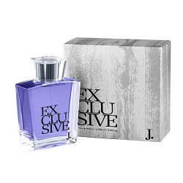

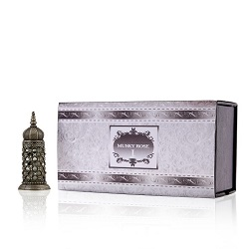

|  |  |
| --- | --- |
| *Name* | *Fragrances* |
| *Color* | ***Silver*** |
| *Size* | ***500ml*** |
| *Brand* | ***Chloe*** |
| *Price* | ***PKR 350*** |

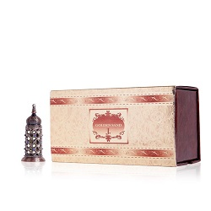

|  |  |
| --- | --- |
| *Name* | *Fragrances* |
| *Color* | ***Brown*** |
| *Size* | ***250ml*** |
| *Brand* | ***Chloe*** |
| *Price* | ***PKR 350*** |

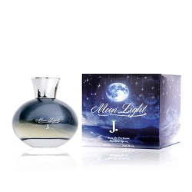

|  |  |
| --- | --- |
| *Name* | *Fragrances* |
| *Color* | ***Dark Blue*** |
| *Size* | ***300ml*** |
| *Brand* | ***Chloe*** |
| *Price* | ***PKR 350*** |